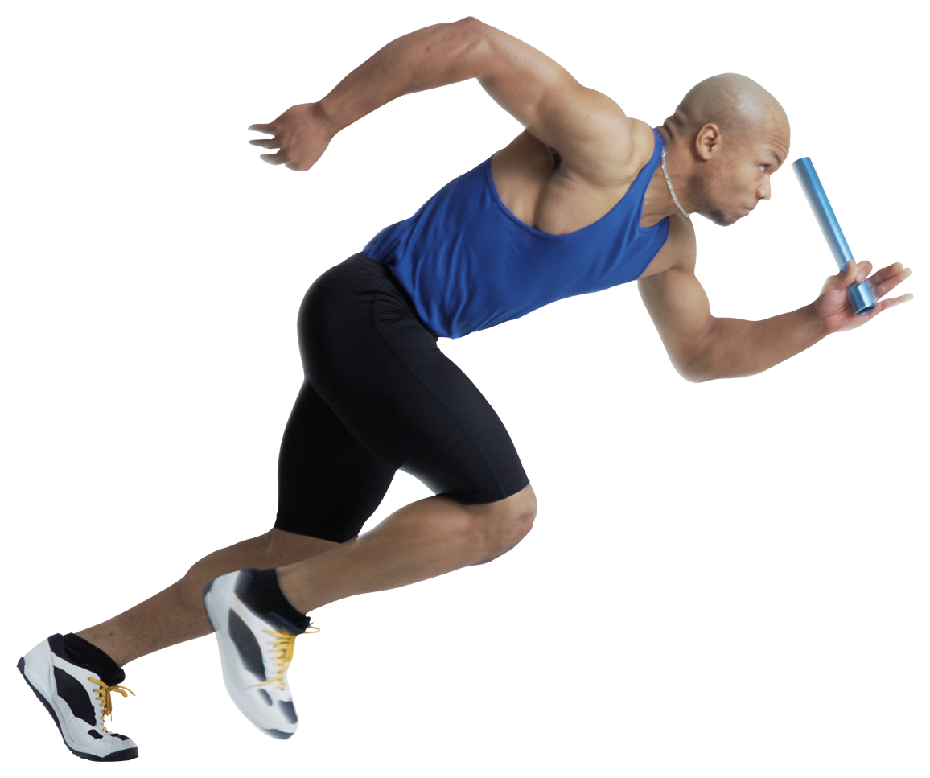 2016 Standard Chartered Mumbai Marathon
A teenager at 14, Nina Foundation is going places! What we truly believe in…. “Walking together for a wonderful tomorrow” is exemplified by our consistency through participation in the 2016 Standard Chartered Mumbai Marathon held this year on Sunday, January 17th. Nina Foundation this year, too for the 12th time, encouraged many Friends with Spinal Cord Injury and members to be part of this exciting event. And yes, they did! To make it a GREAT STIMULATING SUNDAY for them and others, too!!

As usual, the designated area outside St. Xaviers College at Metro, Mumbai was allotted to Nina Foundation, whose Team comprising of very enthusiastic friends supporting its cause, that included members with Spinal Cord Injury and their families, its Trustees, volunteers and friends met at 6.45am sharp. Some had collected their Marathon kits in advance and those who had not, collected theirs too and all got ready for the event. This year each numbered participating runner had a ‘buddy’ to keep up with our SCI friends. So each one and their ‘buddy’ completed the Marathon with good cheer, camaraderie and pride. Debonair Bollywood and TV artiste, Harrsh Mehta, who acted as Manu of the popular “Balika Badhu’, Vivaan of ‘Fanaa’, Sooraj of ‘Pyar Tune Kya Kiya’ and Rohan in ‘Ek Villain’ was this year’s NF celebrity guest. He is credited for modelling in many commercials, too.

This year, too, the day was quite sunny, yet cool enough to be pleasant and needless to say, it was indeed a beautiful Sunday morning! NF marathoners moved on gracefully with renewed confidence and hope spreading joy as supporters cheered egging us to move on ahead and succeed in this ‘annual ritual’! Seniors who also participated, waved and did a ‘thumbs up’ to our ‘stars’. What a superb feeling to be a part of NF! As they passed by, Friends of Nina Foundation acknowledged these greetings with smiles and joy.

This year saw many more participants and that it continues to grow in numbers. It was great fun to see so many citizens, too, participate by wearing colourful fancy dresses including that of Superman!! There were many who had social messages to convey. THIS IS THE SPIRIT OF SOLIDARITY of Mumbai citizens and also that of NINA FOUNDATION.

However, this year was ultra special! Prince of all hearts, charming John Abraham, Ambassador of the Standard Chartered Marathon was gracious and sensitive to a request made for him to come and meet NF Friends. There was a flurry of excitement and screams as he came and bowled all with his dimpled smile. Many hearts missed a beat or two (maybe three) when he was brought to where our NF Friends were waiting for a photo-op. Respectful as he always is, John patiently allowed us to have pictures taken with him. Who would miss any opportunity to have a picture with him? And by then, guess what? He stole our hearts away! Thank you John for being YOU! Please know that we will remember these precious moments in times to come.
Hard to forget, eh? Not that we want to!!

Then we had another successful, talented and humble Bollywood actor, Madhavan, who flagged off the Seniors’ Run also oblige us with some photographs with him. Thank you Madhavan!

All good things come in three-s! So how can we forget to mention the last?

We met with blessed, 104-year young Fauja Singh. Oh such a vibrant and active person. Bless him! Very simple and unassuming, he stood tall as we took pictures with him. We, at NF, salute dear Fauja Singh. We pray Wahey Guru that he runs many, many more Marathons to encourage others. Other dignitaries like the Governor of Maharashtra, Chi Vidyasagar Rao, Mr. Ashish Shelar, MLA and Head of Mumbai Unit, BJP, Ronnie Screwala, Katrina, to name a few, were all smiles as they cheered and waved out to all as participants passed the podium. What an electrifying atmosphere with these celebrities and the common citizens standing together on this exhilarating Sunday.

Nina Foundation participates in the annual Mumbai Marathon every year. The city’s first event of the year is a platform on which social bonds are strengthened and a place where each one catches up with the other in person. Three cheers to each of you, dear NF friends who stand by and support our common cause!

Special events need a lot of documentation and follow up. This year the onus of paperwork and telephone follow-up fell on kajal Haryani and Oliver D’souza and distribution was done by Sunita, Nisha , Harshad Shinde and Oliver D’ Souza, and of course our dependable Kreate Team, who made beautiful placards within a short span of time. This year we had our youngest volunteer Master Prathamesh Haryani (11 years) in our team with Ms Meeta Sahijwani (MMS Batch Student, we School –Matunga) Our Trustees, Dr. Ketna Mehta, Dhaval Mehta, Dr. Parinaz Humranwala and Vidya Shenoy heartily participated. This time also around too there was live music in our designated area. There was an artist and a potter at his wheel for demonstration. Refreshingly different. There were food packets, tea and coffee offered to one and all by the Marathon volunteers.

Cheers to our ‘Champions with Disability’, who were rewarded with a medal each! From us, Trustees, Divine Grace and Blessings to each of you and your families!

Now, now, aren’t you waiting the next Marathon?
WE, TOO!

As the traditional Gaelic Blessing is
“ May the road rise up to meet you.
May the wind be always at your back.
May the sun shine warm upon your face,
The rains fall soft upon your fields
And until we meet again,
May God hold you in the palm of His Hand.”

Wishing each of you a safe, healthy and successful 2016!

Report By : Vidya Shenoy

